**Assignment 2**

**Thimmy Stenlund ts222ub**

**Webbprogrammerare HT2018**

**Date: 2019-02-20**

# Use Case Model (Page 1)

# Use Case for “Play Game” (Page 3)

# Time Log (Page 4)

# Use Case Diagram (Page 5)

# Class Diagram (Page 6)

# Play Game State Machine Diagram (Page 7)

**Use Case Model**

## UC 1 Start Game

Precondition: none.

Postcondition: the game menu is logged in console.

### Main scenario

1. Starts when the user wants to begin a session of the hangman game.
2. The system presents the main menu with a title, the option to play a standard game, the Hang The Man version of the game and quit the game.
3. The Gamer makes the choice to play the standard game.
4. The system starts the standard game (see Use Case 2).

*Repeat from step 2*

### Alternative scenarios

3.1 The Gamer makes the choice to quit the game.

1. The system quits the game (see Use Case 3)

4.1 Invalid menu choice

1. The system presents an error message.
2. Go to Main scenario 2

5.1 The Gamer makes the choice to play the Hang The Man version of the game.

1. The system loads the alternative Hang The Man version. (see Use Case 4)

## UC 2 Play Game

Precondition: The game is running.

Postcondition: The standard game mode is active

### Main scenario

1. Starts when the user chooses the “Play Standard Game” option in the menu.
2. A random word is selected from an array, which is not shown to the user.
3. For each letter in the word, an underline is displayed.
4. The user can guess letters, if it’s correct – the user can continue. If its wrong, the counter will increase by one.
5. If the user guesses all letters before the counter reaches 8, the user will see a “You Win!” being logged to the console, together with the time it took, and an option to go back to the menu. (see Use Case 1)
6. If the counter goes to 8, i.e. the user guesses wrong letter 8 times, the user will see a “You lose!” being logged to the console, with an option to go back to the menu. (see Use Case 1)

Alternative scenario

2.1 The Gamer wants to leave the game and go back to the main menu. (see Use Case 1)

## UC 3 Quit Game

Precondition: The game is running.

Postcondition: The game is terminated.

### Main scenario

1. Starts when the user wants to quit the game.
2. The system prompts for confirmation.
3. The user confirms.
4. The system terminates.

### Alternative scenarios

3.1. The user does not confirm

1. The system returns to its previous state

## UC 4 Start Hang The Man Game

Precondition: The game is running.   
Postcondition: The game menu is logged

### Main scenario

1. Starts when the user chooses the “Play Standard Game” option in the menu.
2. A random word is selected from an array, which is not shown to the user.
3. For each letter in the word, an underline is displayed.
4. The user can guess letters, if it’s correct – the user can continue. If it’s wrong, the counter will increase by one.
5. If the user guesses all letters before the counter reaches 8, the user will see a “You Win! The Man is Hanged” being logged to the console, together with the time it took, and an option to go back to the menu. (see Use Case 1)
6. If the counter goes to 8, i.e. the user guesses wrong letter 8 times, the user will see a “You lose! The Man is Free” being logged to the console, with an option to go back to the menu. (see Use Case 1)

Note: The difference between the game mode “Standard” and “Hang The Man” is purely graphical. In standard, you are aiming for not hanging the man. In “Hang The Man” you try to actually hang the man.

## Use Case for “Play Game”

### Scenario: Winning the game

A gamer wants to play the standard version of the hangman game. The game displays a menu to display the choices for the gamer to choose from. The gamer then chose to initiate the “Play Game” menu choice. The game boots up the standard version of the game, choosing a word at random from the pre-defined array and display several underlines consistent with the number of letters in the (now hidden) word. The gamer will then guess letters. As the gamer finds the correct letters and unveils the word, the game prints out “You win!”.

### Scenario: Loosing the game

A gamer wants to play the standard version of the hangman game. The game displays a menu to display the choices to choose from. The gamer then chose to initiate the “Play Game” menu choice. The game boots up the standard version of the game, choosing a word at random from the pre-defined array and display several underlines consistent with the number of letters in the hidden word. The gamer will then guess letters that are not found inside the word. As the gamer guesses the incorrect letters more than 7 times, and thus hangs the man, the game prints out “You lose!”. The options to either Quit or go back to Main menu is then presented to the gamer.

### Time Log

|  |  |  |  |  |  |
| --- | --- | --- | --- | --- | --- |
| Date | Time | Task | Actual  Time |  | Analysis |
| 12/2 2019 | 4h | Model w/ UML | 3 hour | Close to the calculated time. | |
| 13/2 2019 | 30m | Add Diagrams (UML) to Project Plan | 30m | - | |
| 13/2 2019 | 4h | Start the game with a const word. | 2h | Modified to start with a constant array of words | |
| 14/2 2019 | 2h | Construct a counter for number of guesses to fail. | 30min | Took less time than expected | |
| 14/2 2019 | 2h | Arrange a way to display the hanging. | 1h | The route of “easy” was taken. It displays “_” for each unknown letter in the randomly selected word. | |
| 15/2 2019 | 2h | Timer for the game. | - | Not Implemented (Saved for Assignment 3) | |
| 16/2 2019 | 4h | Create a “menu” to start the game or optional game mode. | 4h | Due to issues with reloading the menu from playing the  game, it took about the time set aside to get it to function. | |
| 20/2 2019 | 30min | Turn in  Assignment  2 | 30 min | - | |

Use Case Diagram

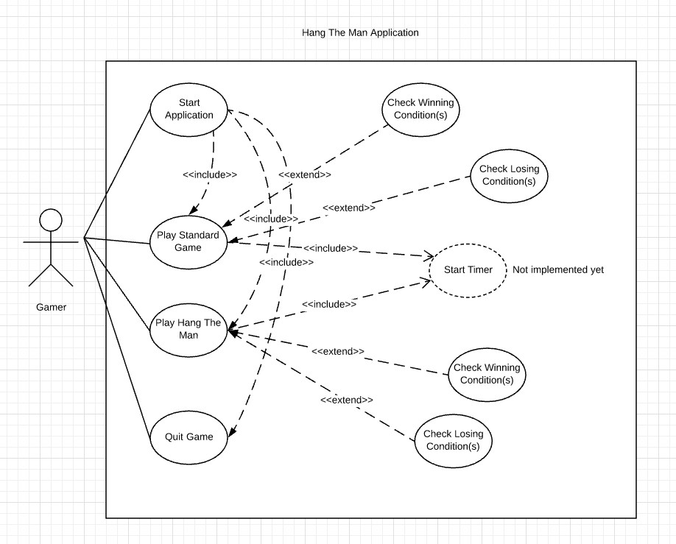

Class Diagram for HangTheMan Application

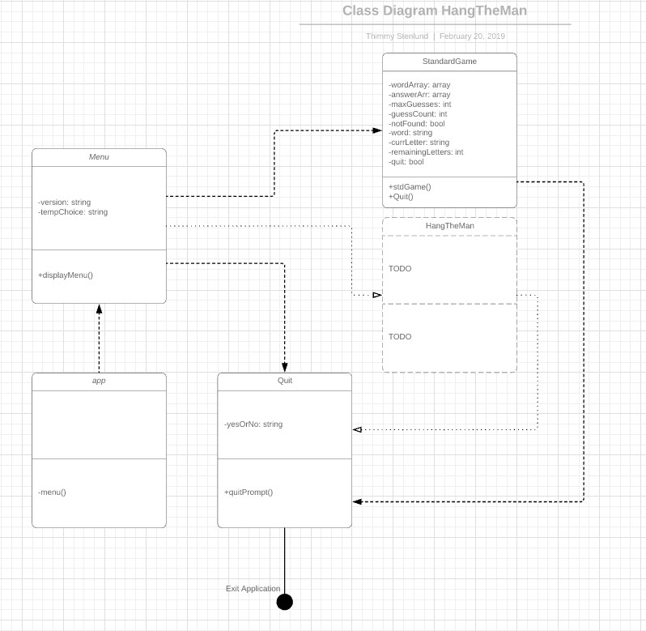

Play Game State Machine Diagram

